PARTNER CONNECT
- Snowflake has agreed with some third parties or partners to connect easily and integrate.
- This helps various organizations to integrate the tools they need for their business and connect with data in snowflake.
- Terms and conditions are dictated by partners and not by snowflake.
- There is a list of supported partners (like you can see in partner connect section).
- Account admin is the role which is actually required to create a partner connect trial account with email verified at snowflake.
Here is where you can check out under home page section in snowflake
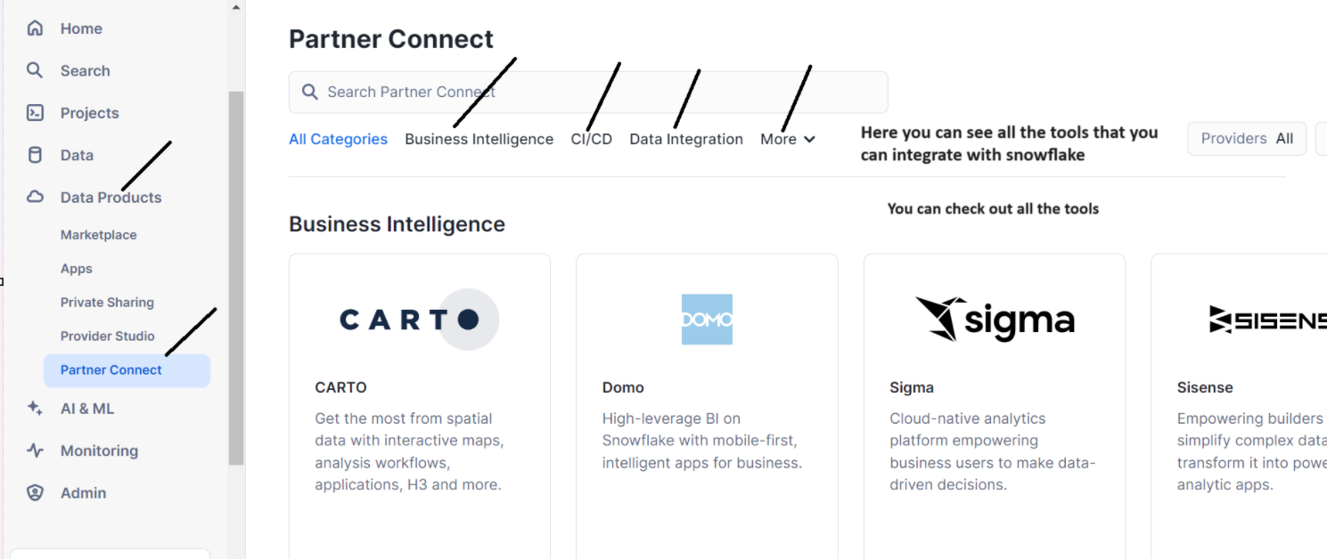
- Once you connect, a list of objects gets created in your snowflake account
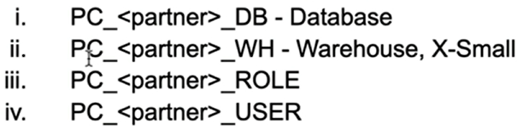
- You can choose to use the existing snowflake objects by updating the partner application preference.
- User can also be altered to change the password for PC_<PARTNER>_USER
- Access should be given to PC_<PARTNER>_ROLE, if objects are owned by role other than PUBLIC.
Let us see a demo
Go to home pagedata products partner connect select any tool by clicking on it as shown
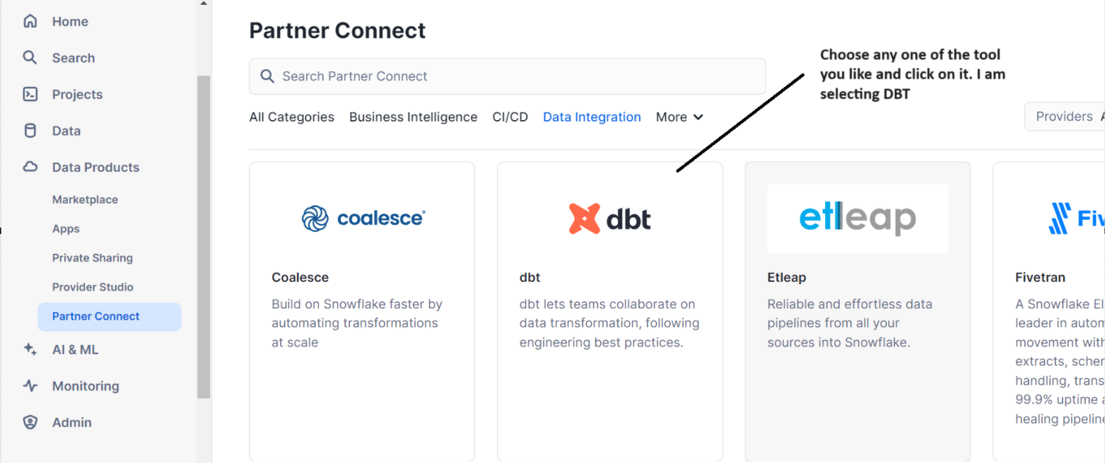
As you see by default partner connect DB, WH, ROLE & USER will be created once you click connect
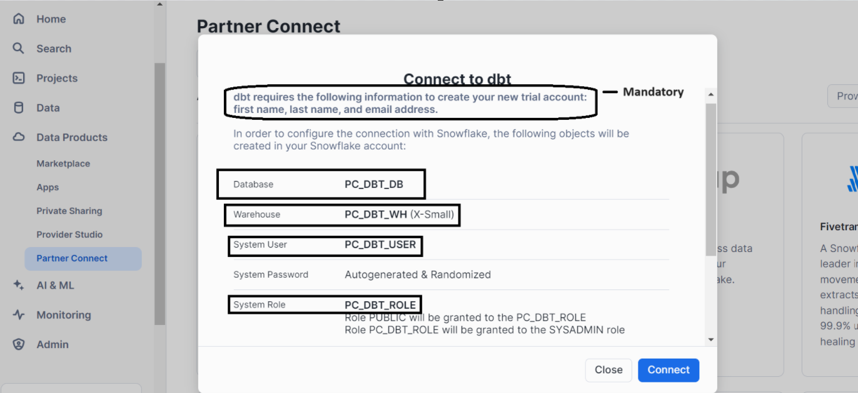
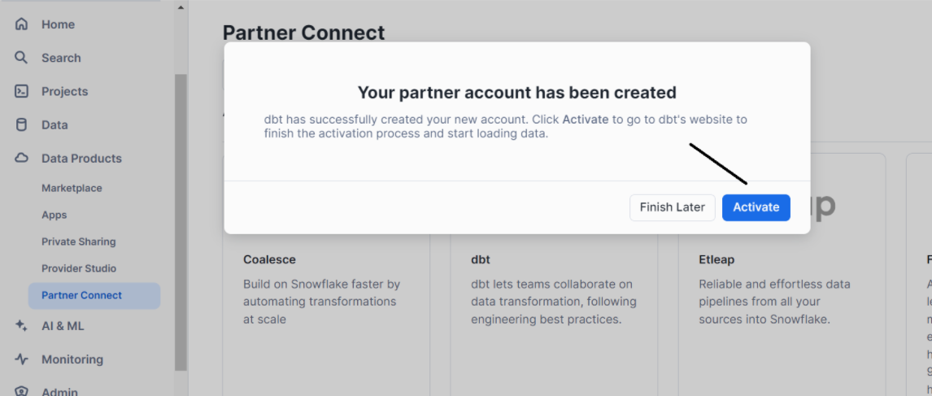
Once you click activate, a link opens as shown where you have to fill the details complete your registration
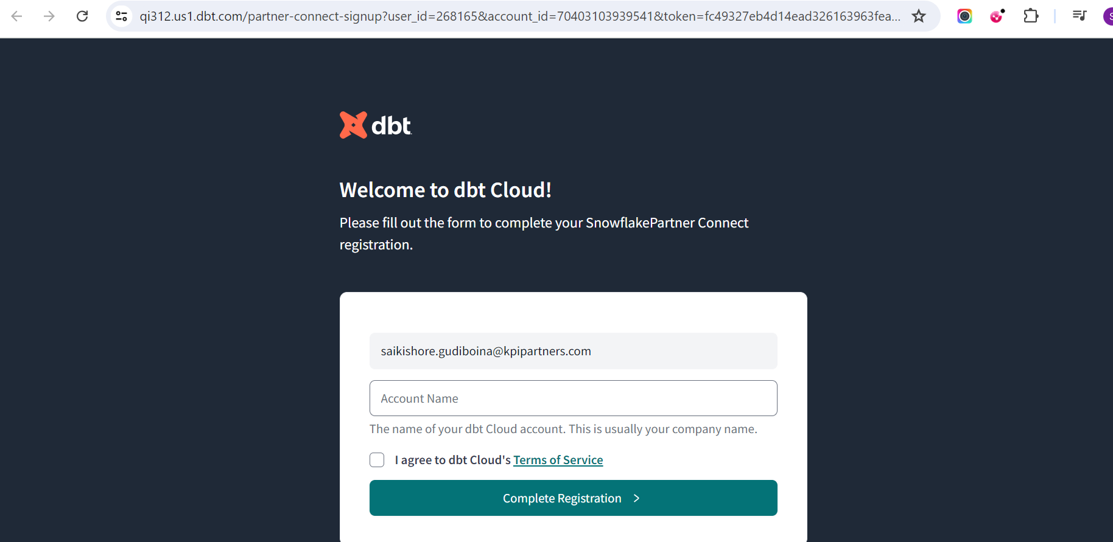

Now, let’s check whether partner connect DB, WH, ROLE and USER are created or not.
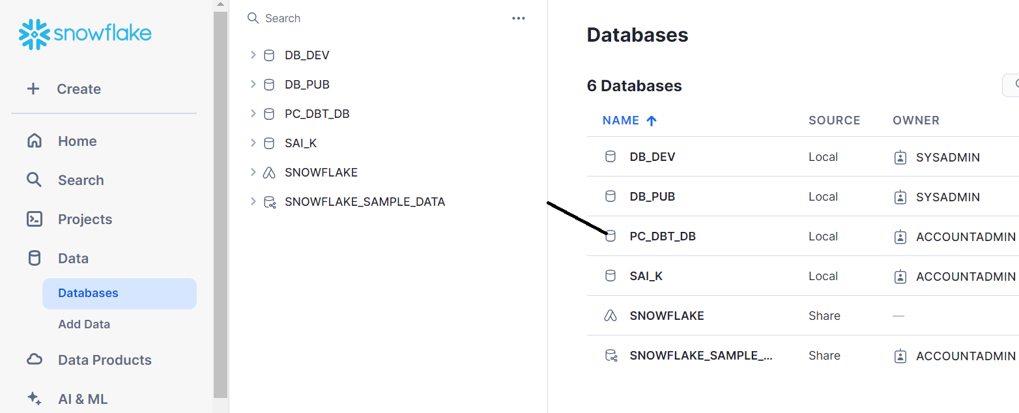
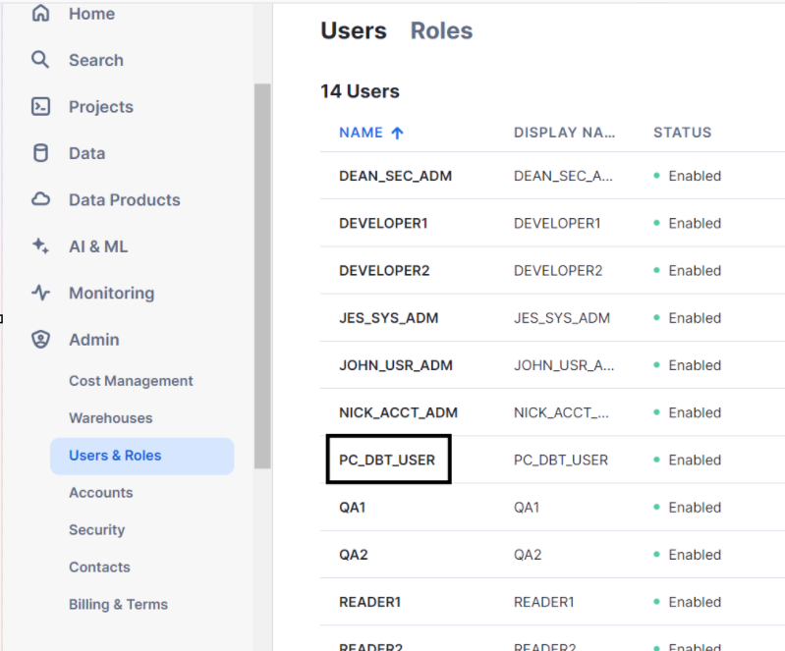
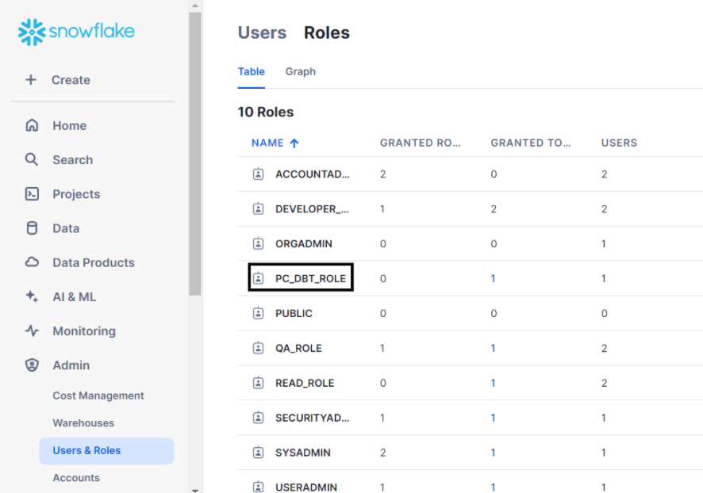

- Trouble shooting
- Connection already exists – in this case either you have created it earlier or it was initiated by a partner
- DROP objects
- Contact snowflake support to clear the connection and remove the checkmark.
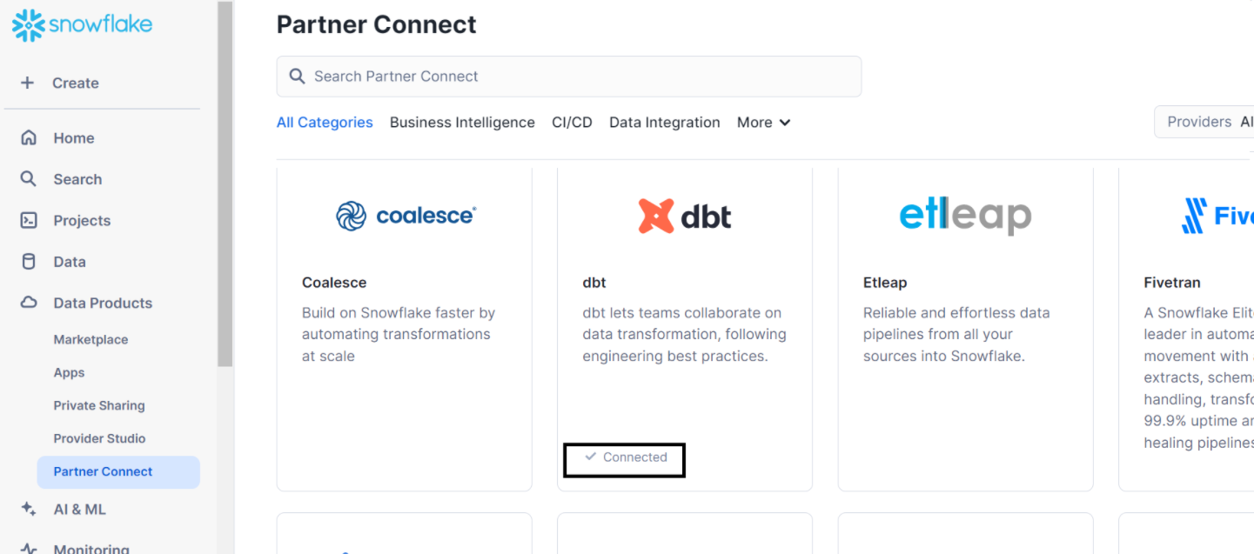
Now, let’s drop the objects
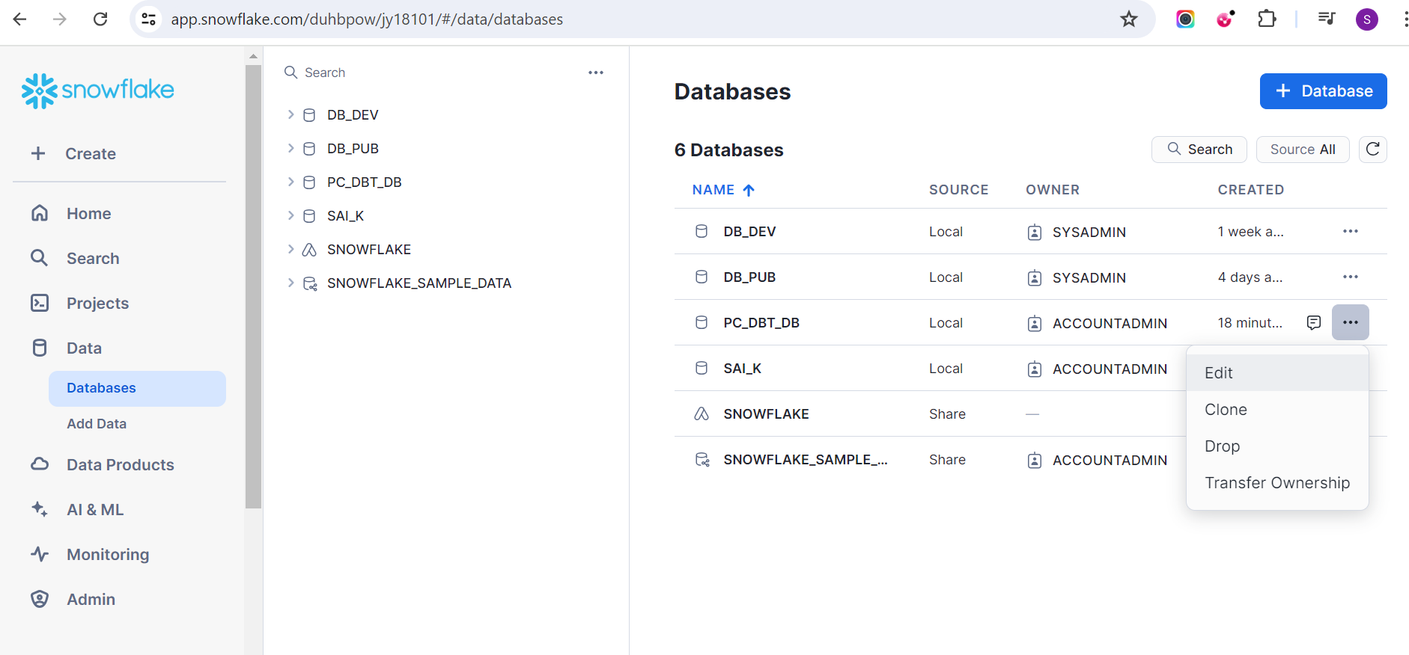
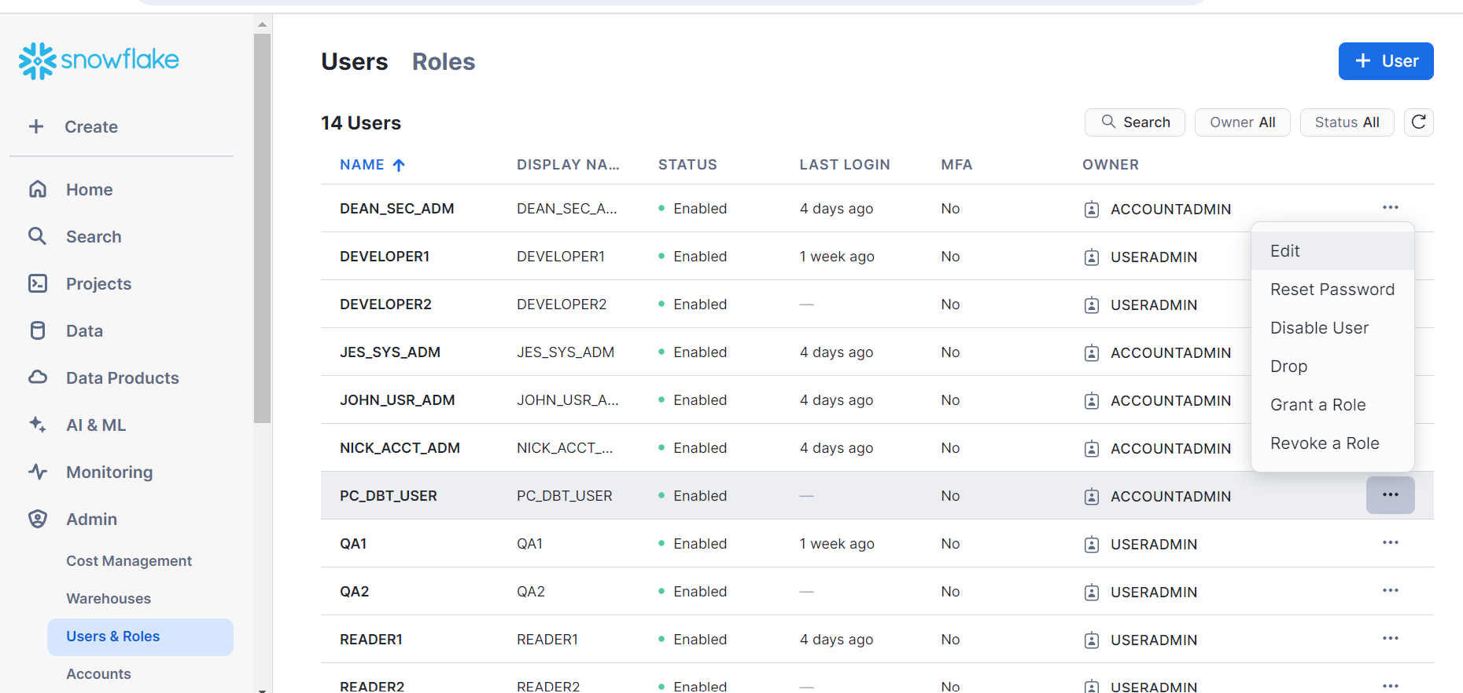
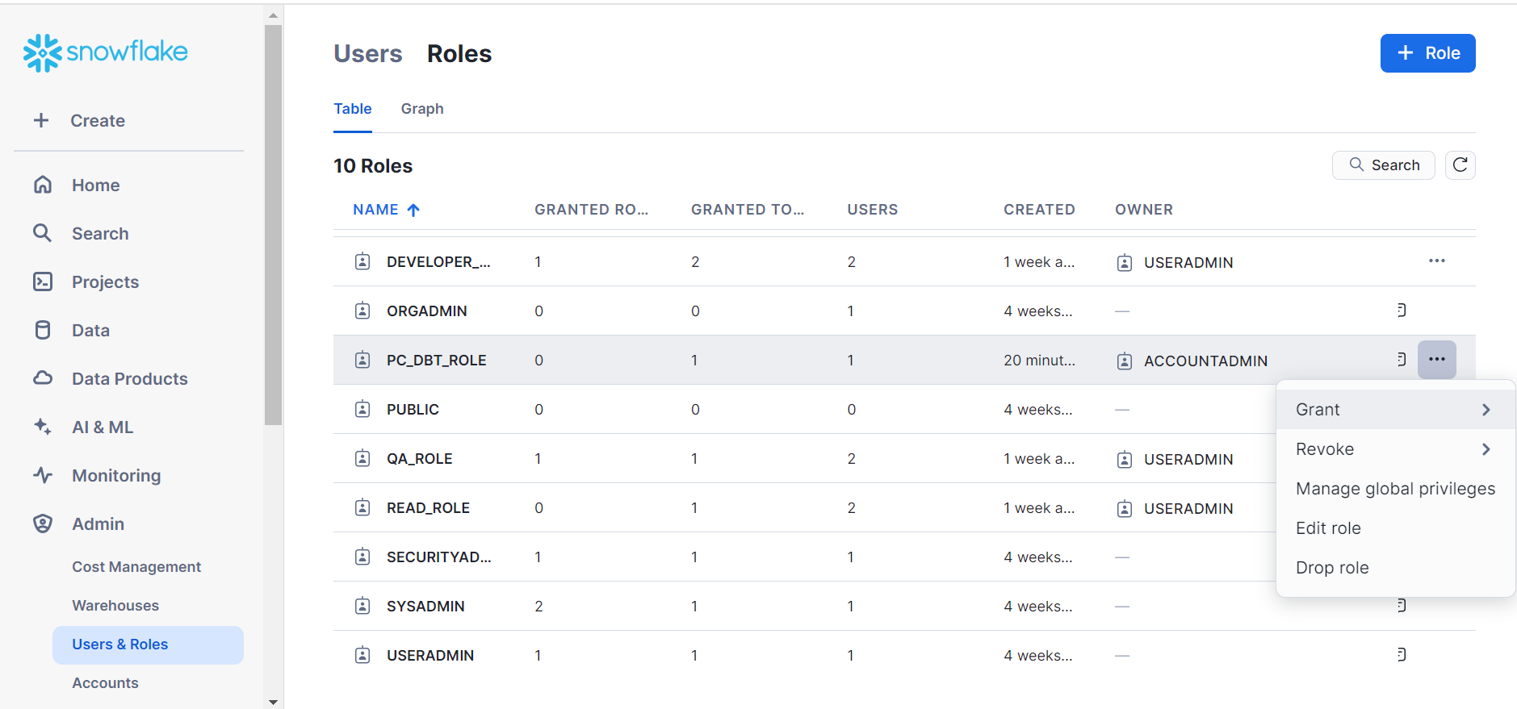
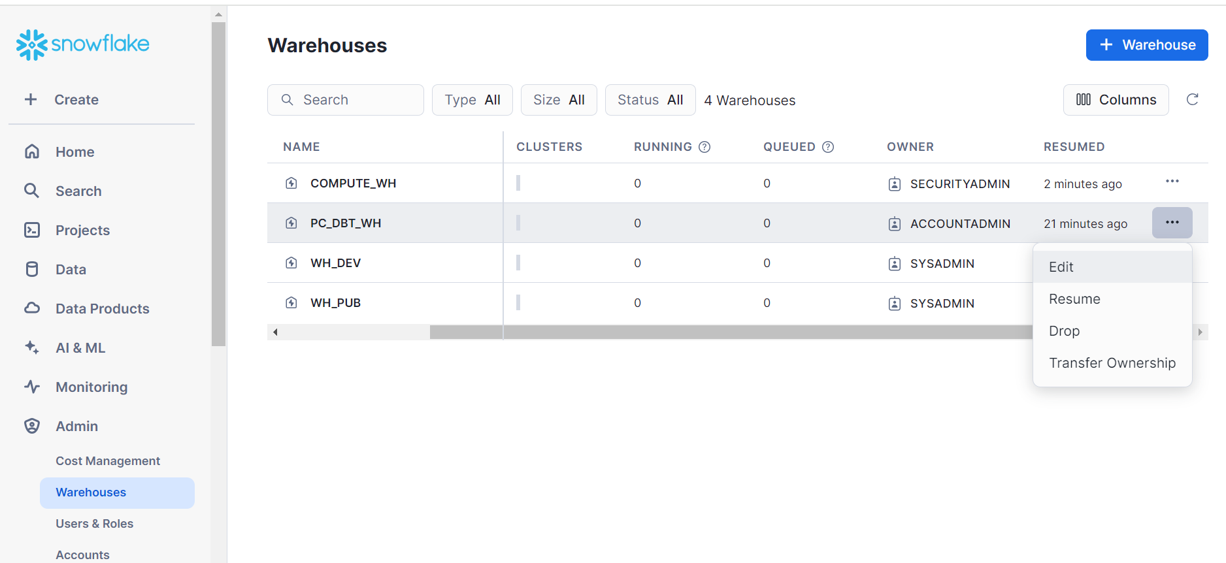
Once we have dropped all the objects, then go back to partner connect in snowflake and ask the snowflake support to remove the checkmark and then later validate the objects.

That’s all about PARTNER CONNECT,
THANKS

